**Lab 4 - David Louis Roy II**

4.

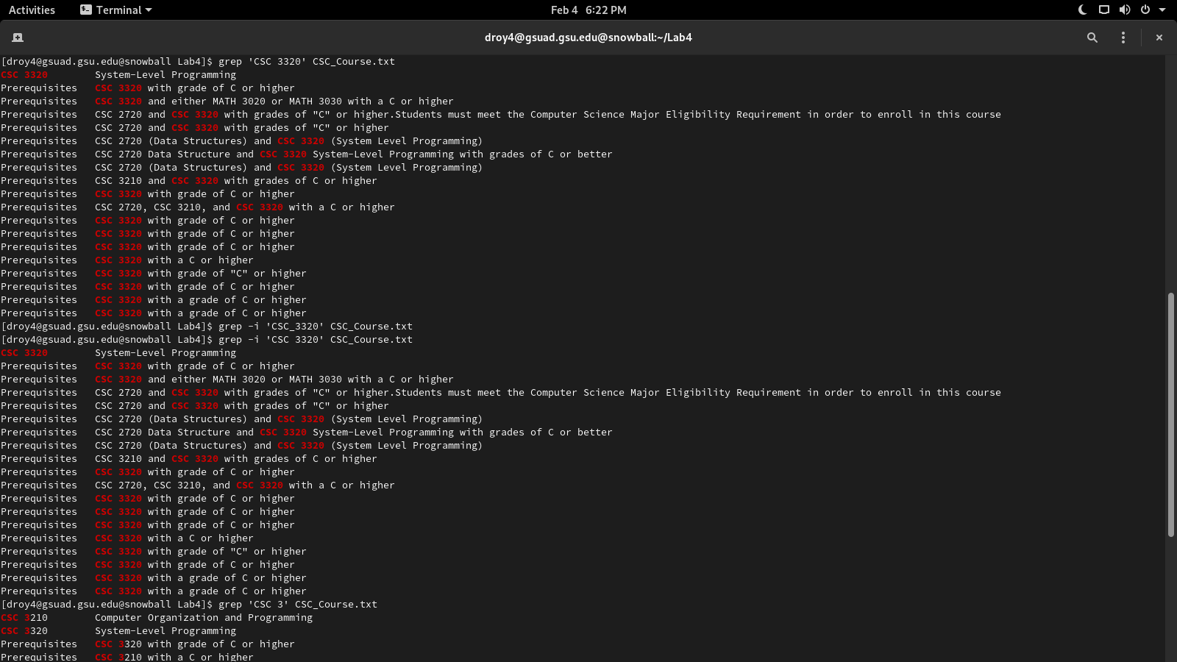

This command searched through the file specifically for the string ‘CSC 3’.

**5.**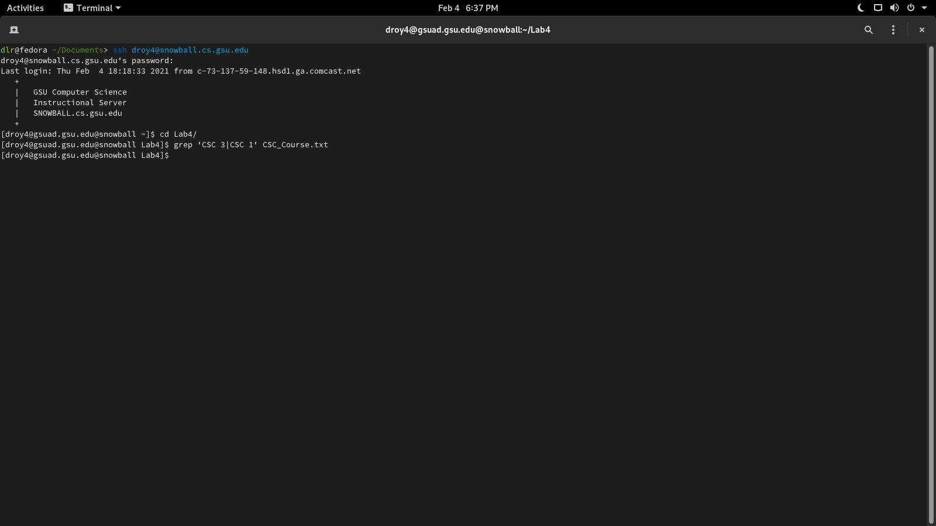

This command didn’t match anything, because it doesn’t apply the syntax of special characters like ‘|’ .

**6.**

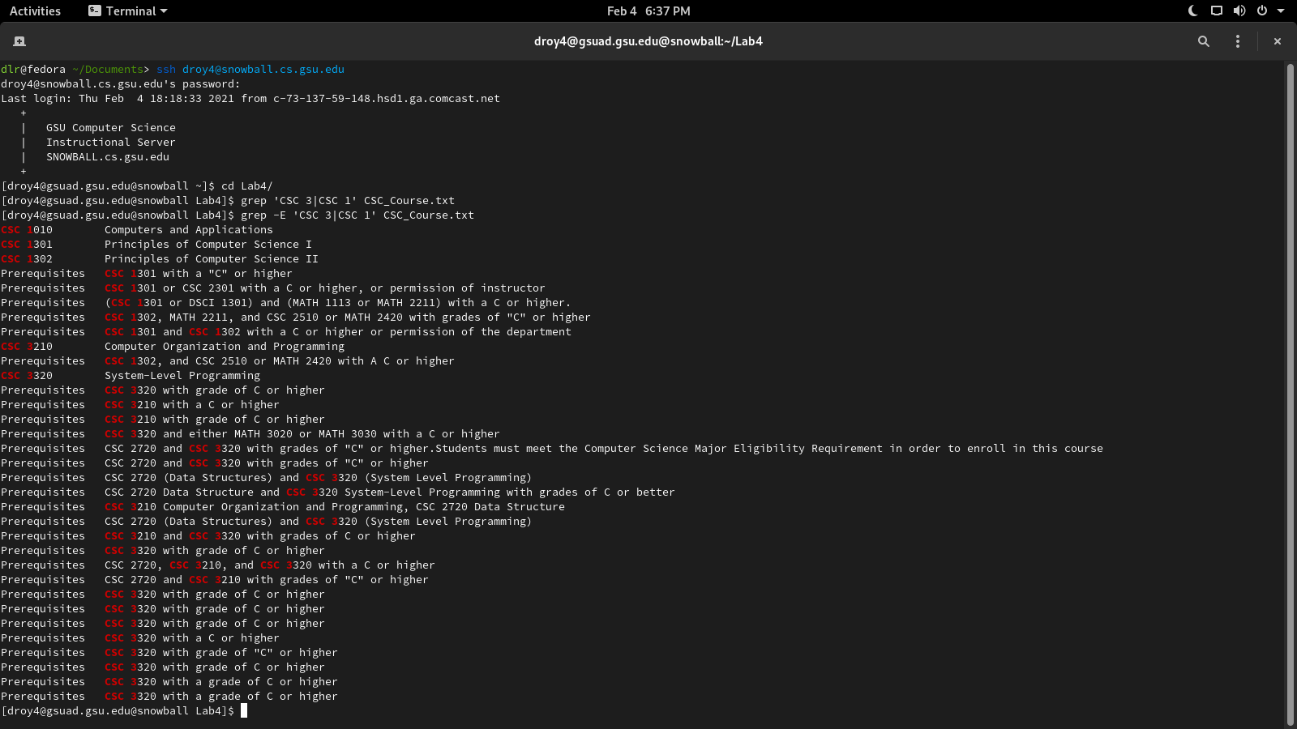

This command searched through the file for a string that matched ‘CSC 3’ or ‘CSC 1’.

**7.**

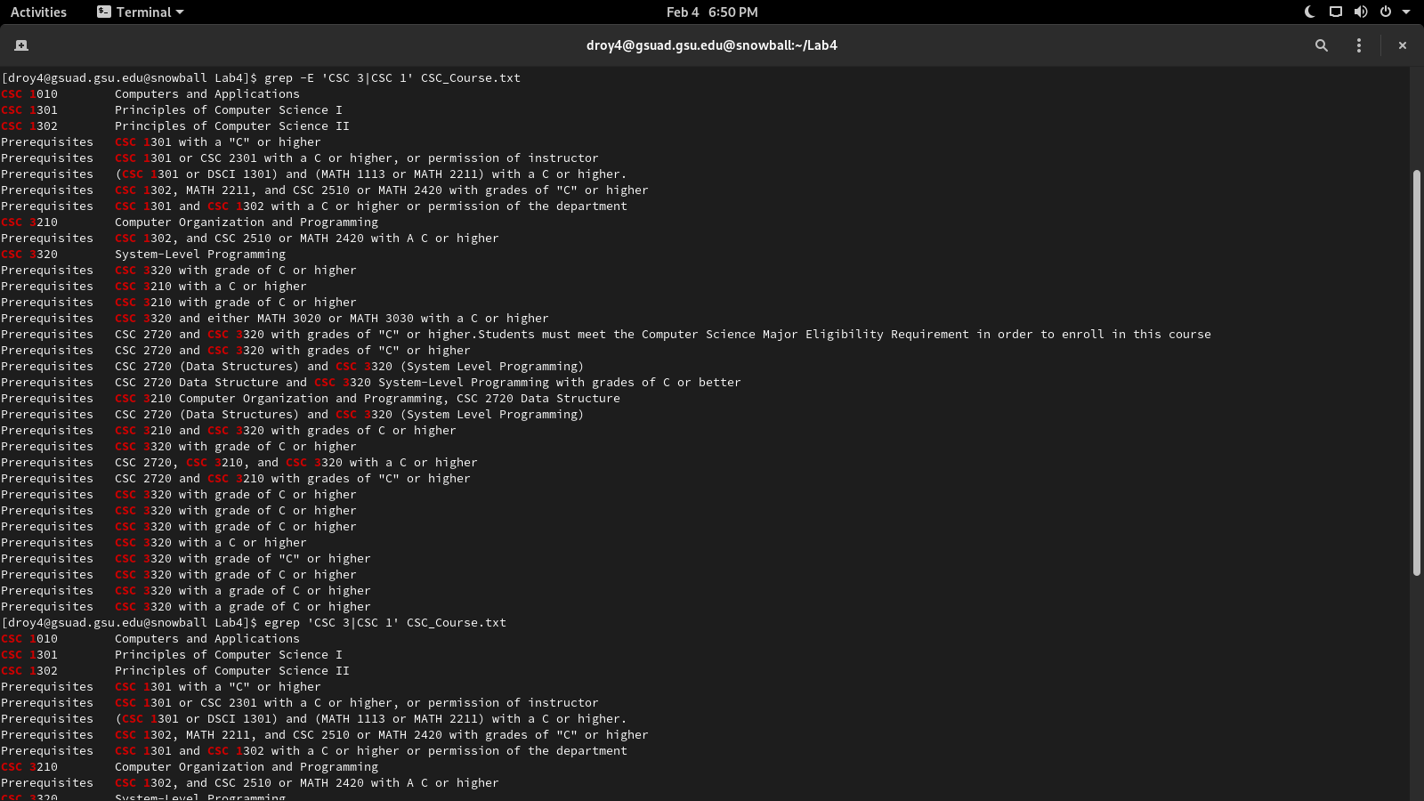This command does the exact same thing as command #6 does, because they both accept extended regular expressions.

**8.**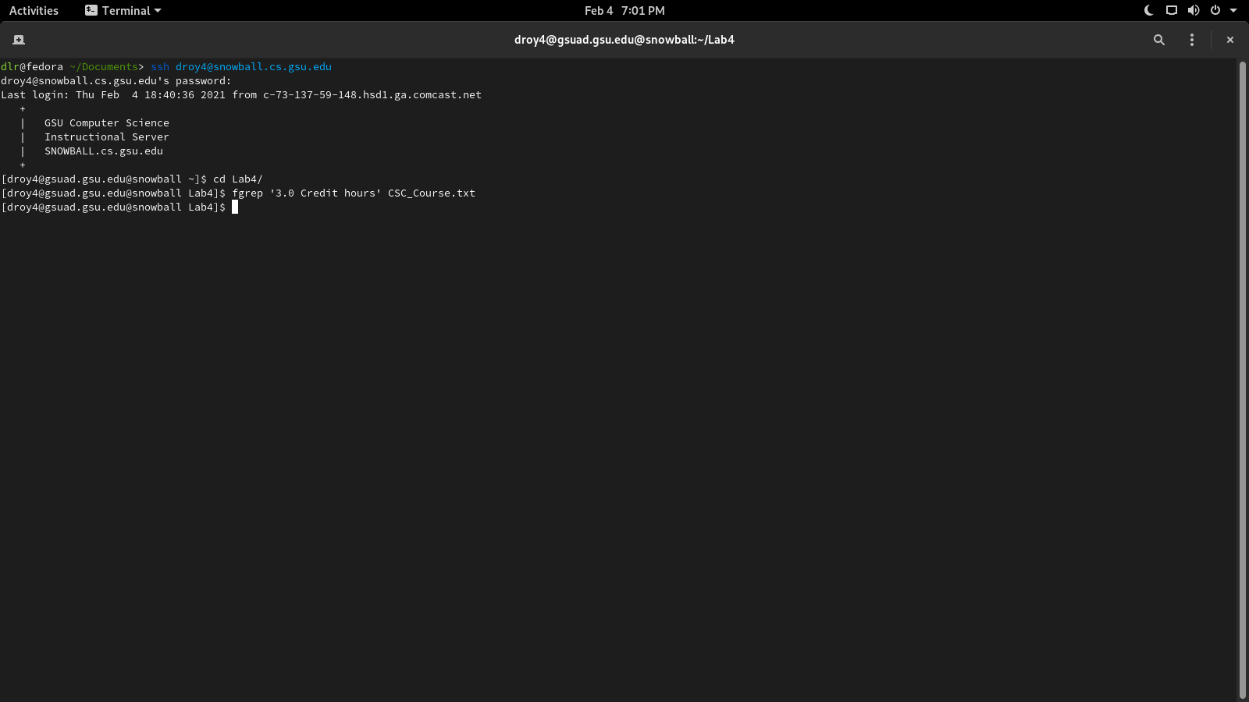

This command searched for the string ‘3.0 Credit hours’, but it didn’t find it, since it only matches with this string.

**9.**

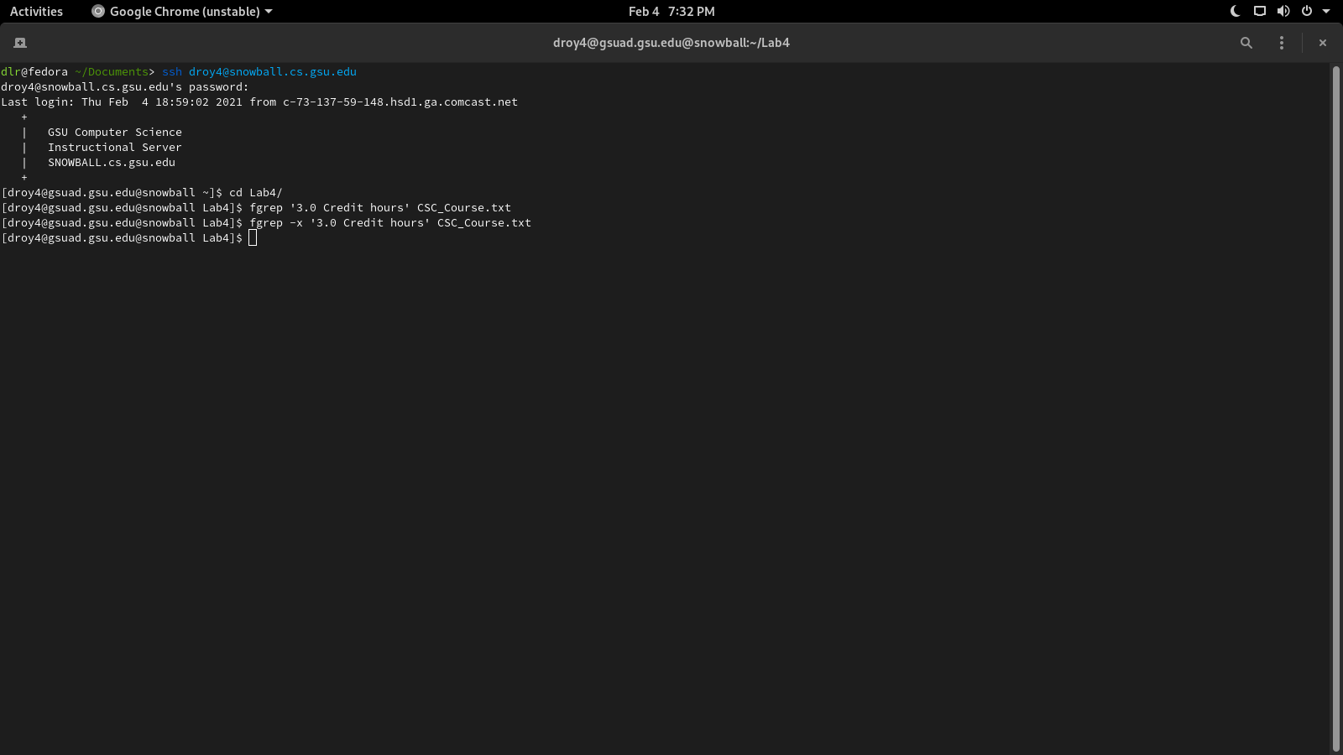

This command searched for the string ‘3.0 Credit hours’, but only matches when the line starts and ends when the string starts and ends.

**10.**

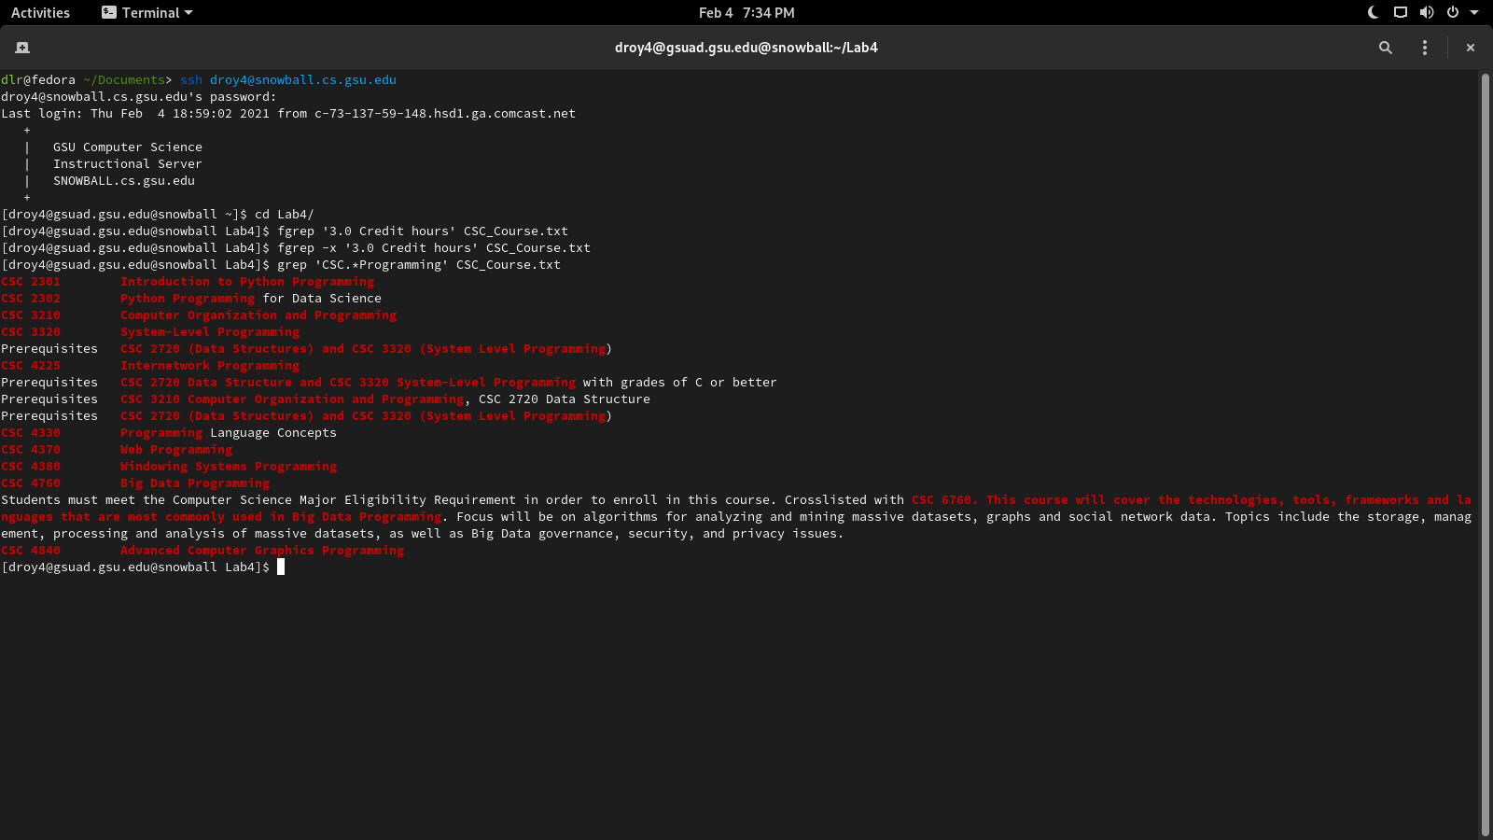

This command searched for and matched any strings with ‘CSC’, that are followed by the word ‘Programming’.

**11.**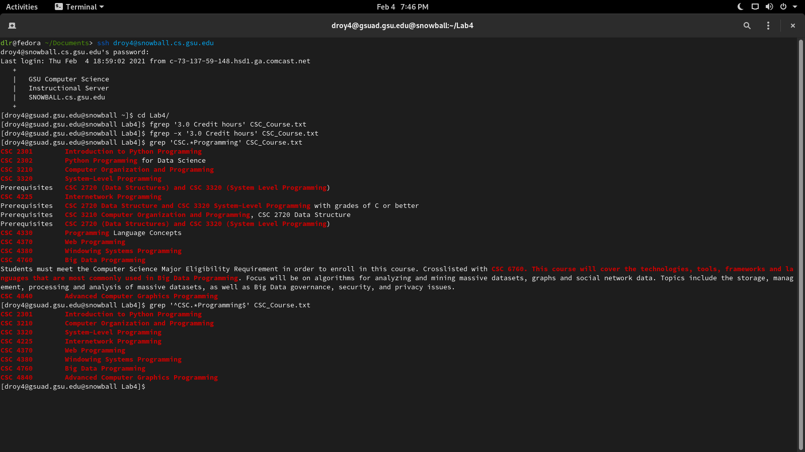

This command searched for and matched lines that started with ‘CSC’ and ended with ‘Programming’.

**12.**

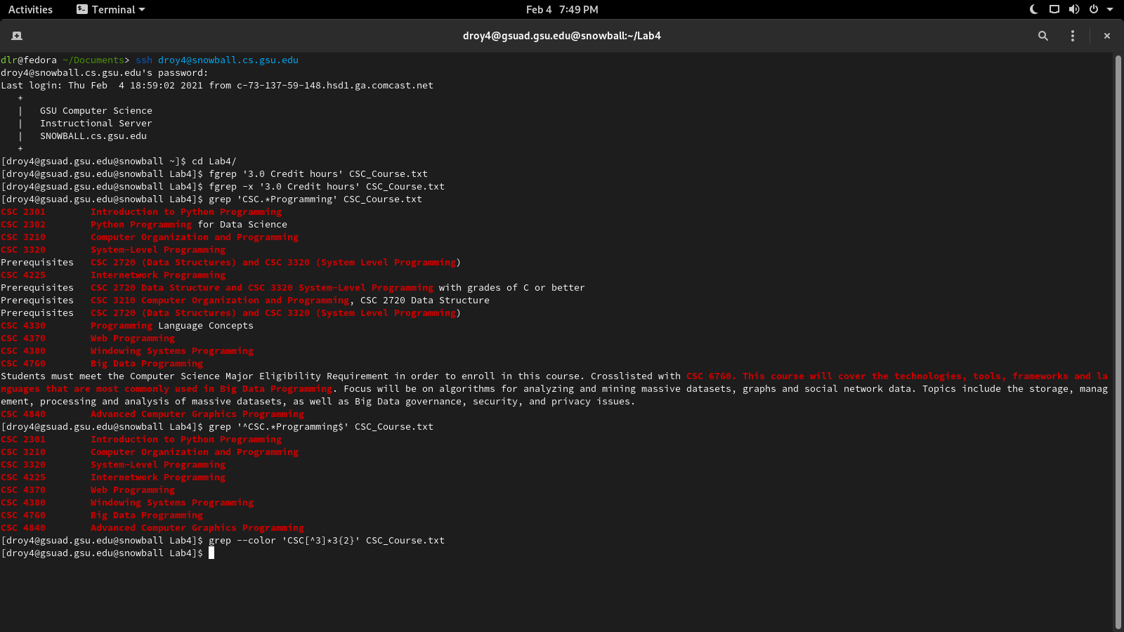This command can’t use the characters ‘{‘ or ‘}’, so it does nothing.

**13.**

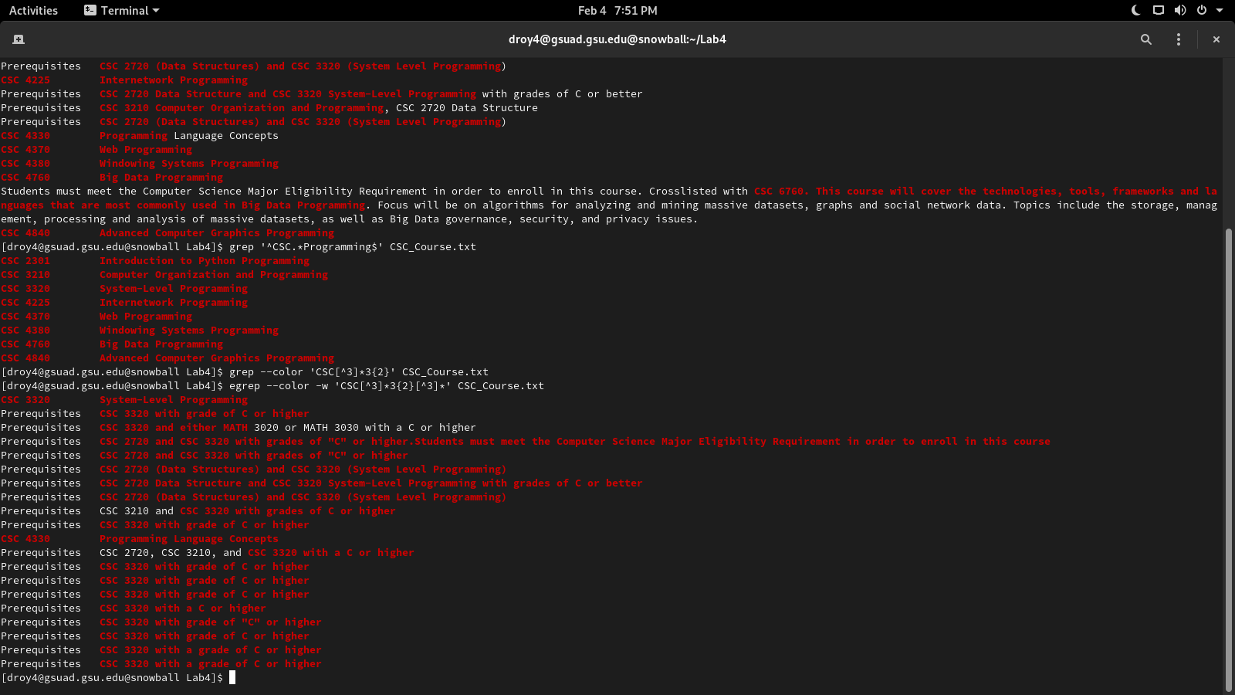

This command matches results that have ‘CSC’, everything that’s not 3, matches 2 of the number 3, matches what is not 3 again, and then matches what’s in this set.

**14.**

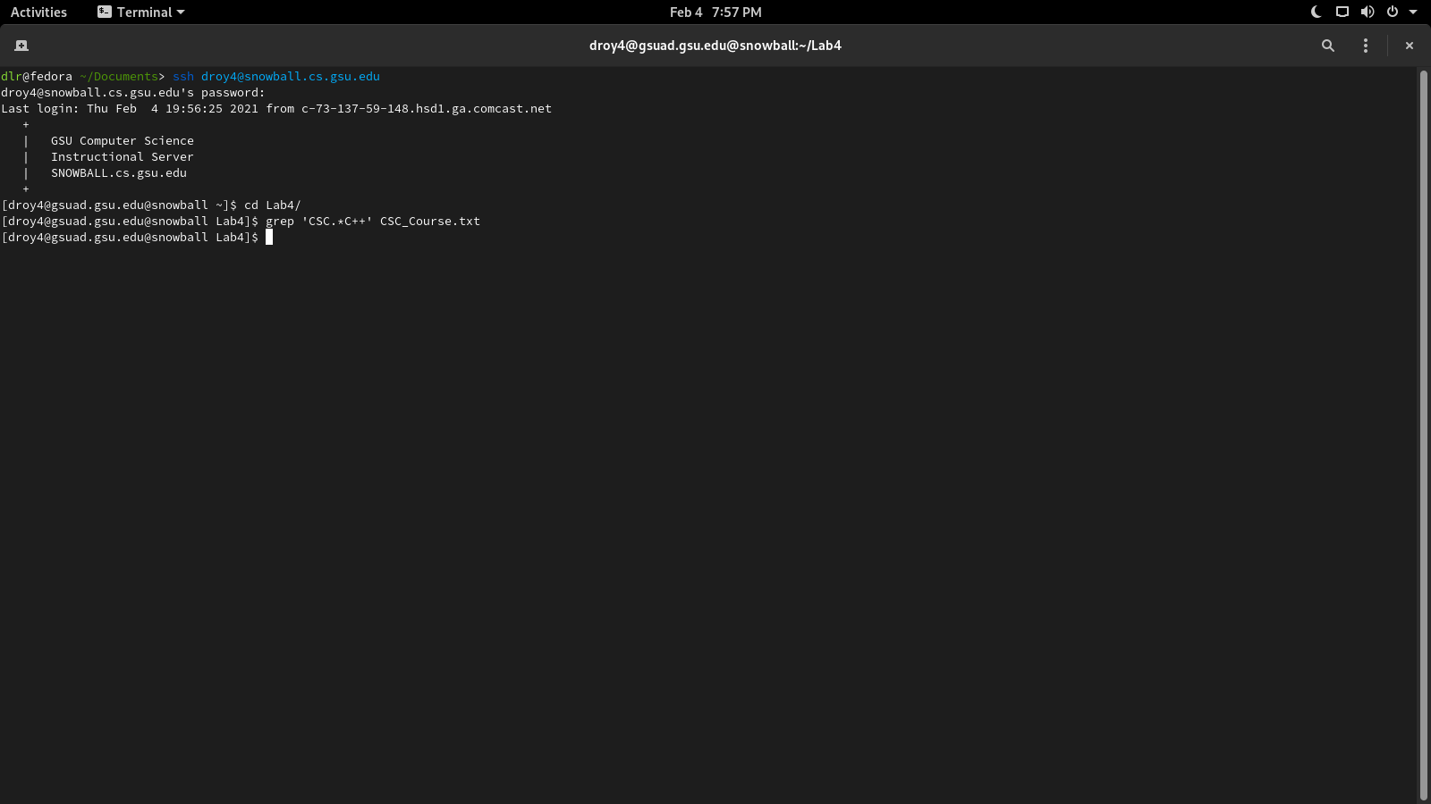

This command gives no output.

**15.**

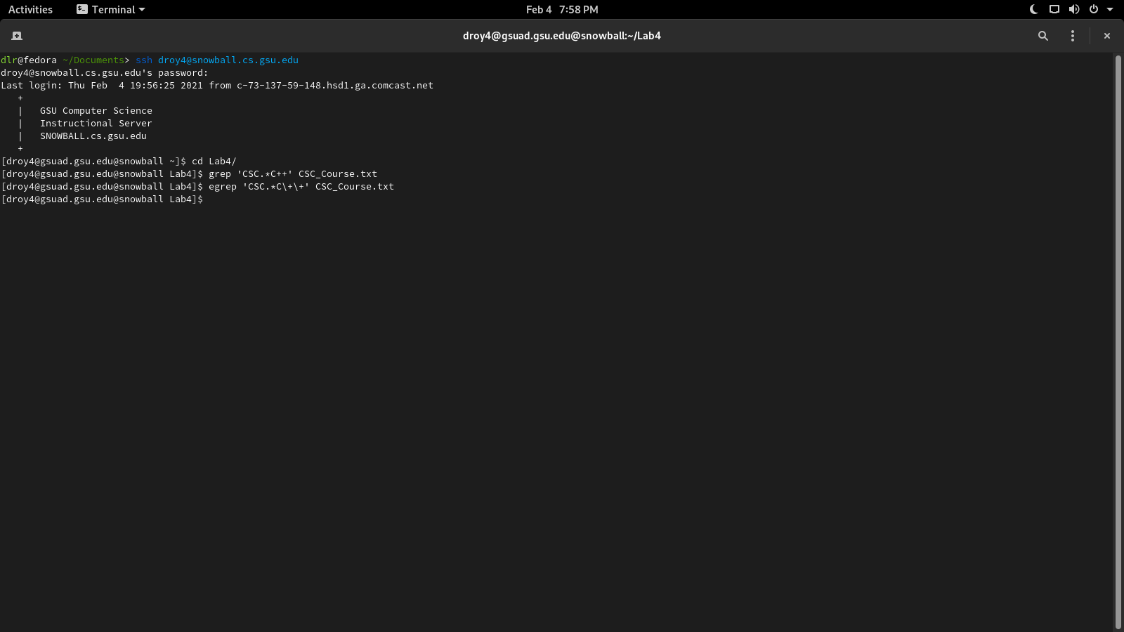

This command gives no output.

**16.**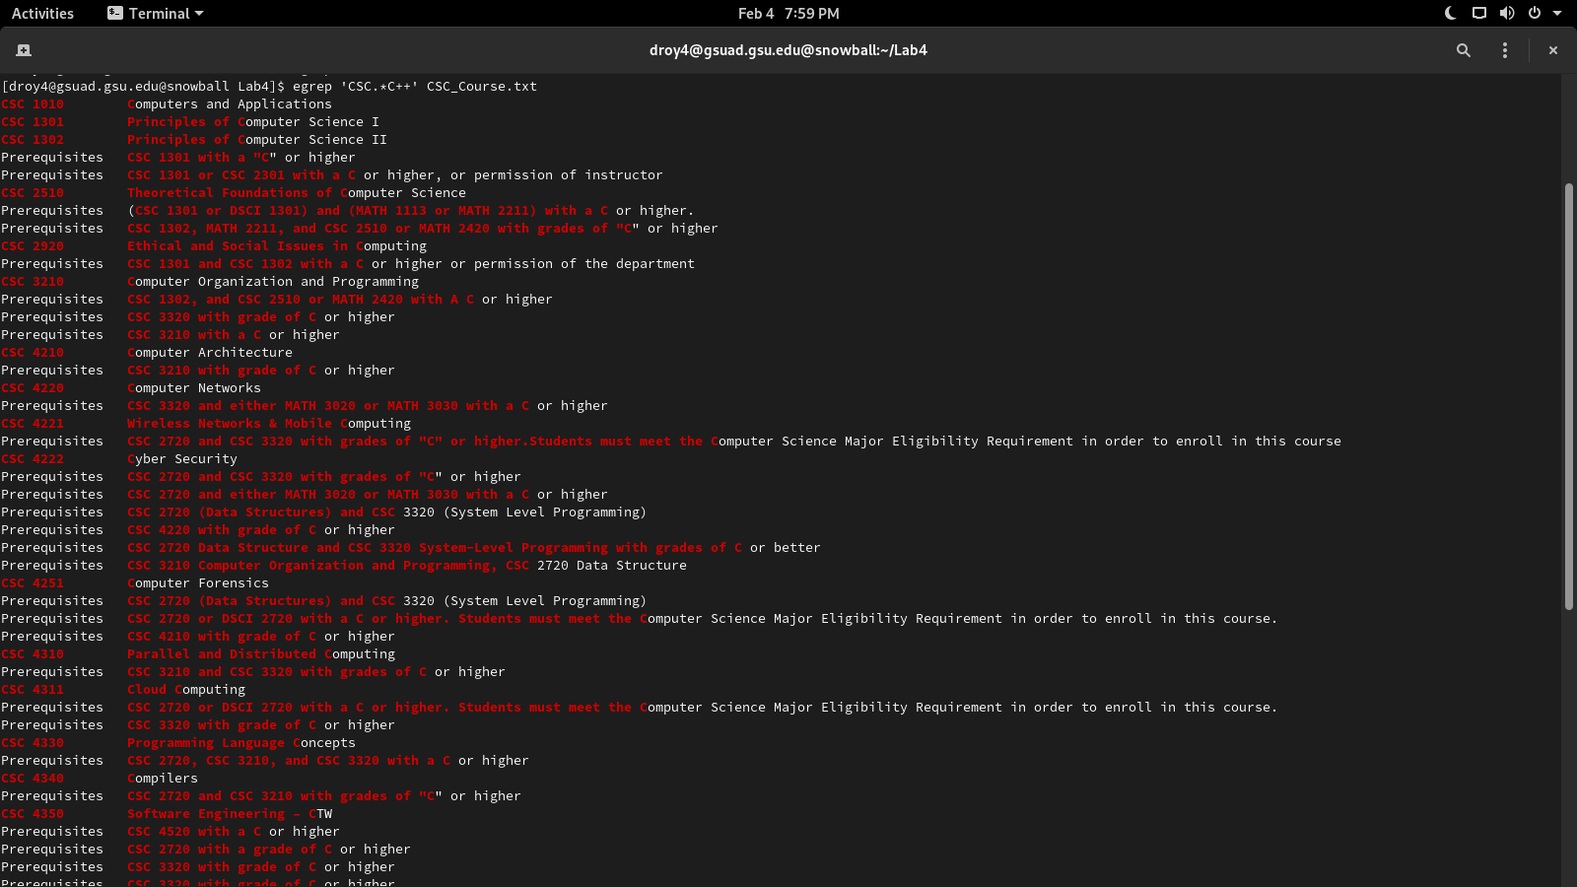

This command matches the string ‘CSC’ with anything until ‘C’ is reached.